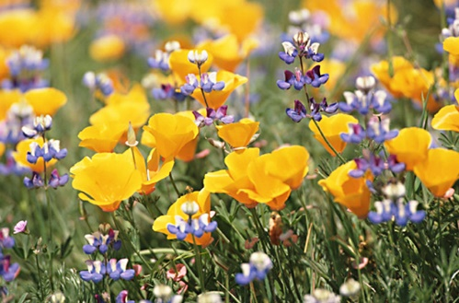
CGCI 2017 Wildflower Conference
March 27-29, 2017
Kernville, California

Join us for the CGCI 2017 Wildflower Conference in Kernville. The registration fee is $90.00 per person. . . Registration includes all speakers, “Wienie Roast” reception, entertainment, one lunch, one dinner and tours. Other meals will be on your own. The event starts on Monday evening, March 27, with the “Wienie Roast” reception; Tuesday will be filled with interesting and educational lectures; Tuesday evening we will enjoy after dinner entertainment; and the conference concludes Wednesday morning with a tour of a local fish hatchery on the Kern River and the Kernville Museum.
Lodging will be ~$100 per night. You will make your own lodging reservations to Kern Lodge
Before March 18. Phone…760-376-2223
Consider extending your stay following the conference, and enjoy the many opportunities in and around the Kernville area.
Make check payable to: CGCI (Note “Wildflower Conference” on the memo line)
Mail form and check to: Janice Wagner, Registrar
NO CASH ACCEPTED 1100 N Inyo Street, Ridgecrest, CA 93555-5603
760-446-4925 Janice.E.Wagner@gmail.com

No registration after March 18, 2017
Questions? Contact: Merrilee Ray 760-382-6546 MojaveBlue@wildblue.net

REGISTRATION

Name________________________________________ Telephone________________________

Email_________________________________________ District__________________________
Tuesday lunch includes drink and brownie
Check one: Roast Beef Sandwich Turkey Sandwich
Check one: Veggie Soup Clam Chowder Salad
Tuesday dinner includes veggies, roasted potato, salad, rolls, dessert and drink.
Check one:
For Office Use
Deposit Check # __________
Bal Paid check # _____________
Confirmation Sent Lodging Info Sent
Refund Due ________ Refund Check ________

Smoked Tri-tip 1/4 Chicken Baby Back Ribs

